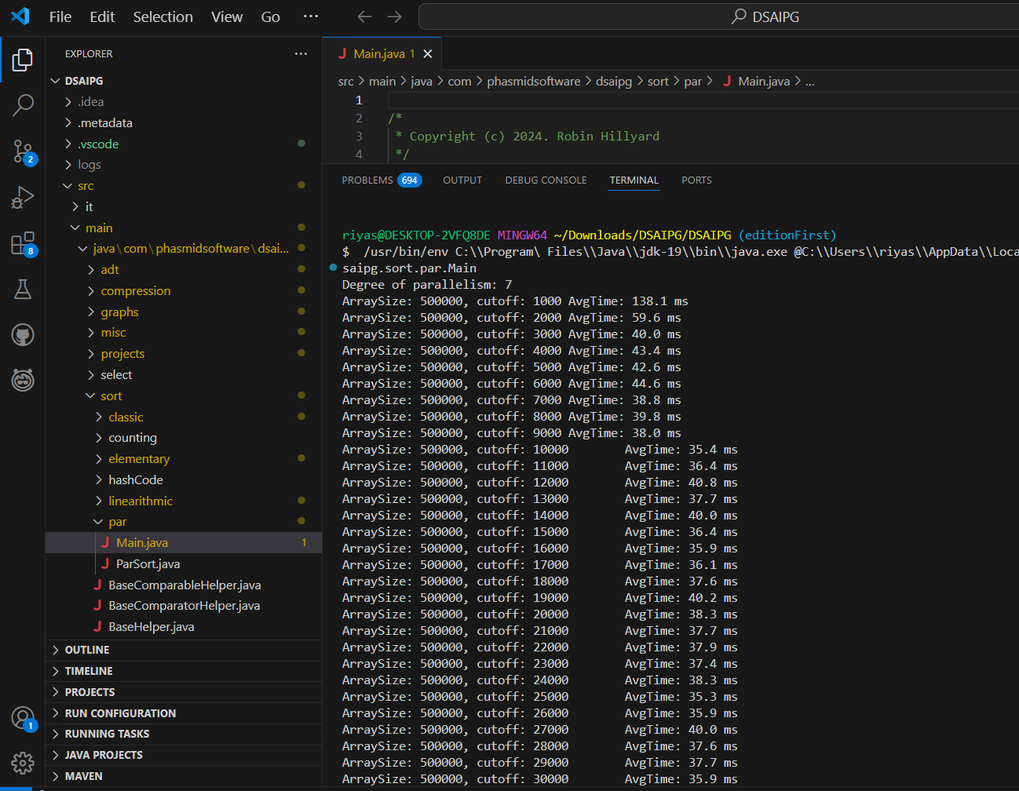

Results and Observations:

Array Size: 500,000
The worst performance was observed at cutoff = 1,000 with 138.1 ms.
The best performance was seen at cutoff = 25,000 with 35.3 ms.
As the cutoff increased beyond 25,000, performance varied but remained close to optimal.

Array Size: 1,000,000
The best time was recorded at cutoff = 7,000 with 69.0 ms.
Performance degraded at both extremes:
cutoff = 1,000: 89.4 ms (high overhead from excessive parallelism)
cutoff = 37,000: 214.3 ms (inefficiency due to excessive sequential computation)

Array Size: 2,000,000
The best performance was achieved at cutoff = 11,000 with 159.9 ms.
The performance fluctuated significantly, with higher cutoffs leading to degraded results.

Conclusion:
Optimal Cutoff Ranges Exist:
For 500,000 elements, the ideal range is 25,000–30,000.
For 1,000,000 elements, the best range is 6,000–10,000.
For 2,000,000 elements, optimal performance was near 10,000–12,000.

Trade-Off Between Parallelism and Sequential Execution:
Lower cutoffs result in excessive task creation overhead.
Higher cutoffs reduce parallelism benefits, leading to increased execution time.

